
University of Science and Technology Houari Boumediene
Computer Science Faculty

FINAL PROJECT TIC

TEAM ID5
Created By: BOUSBAINE Abdelaziz
BENSAID Marouane
BOUALEM Yacine
DJOUDI Idris

Supervisor: BOUCHEKIR Redouane

Table of Contents

- Introduction …………………………………………………. 3
- What is ICT?.............................................................................5
  - Definition.
  - Importance of ICT in Modern Society.
- Categories of ICT Technologies………………………………7
  - Communication Technologies.
  - Why Communication Technologies are Vital.
- Google Services in ICT……………………………………….9
  - Google Workspace.
  - Educational Tools.
- Microsoft Tools in ICT………………………………………..11
  - Microsoft Office:
    - Word,
    - Excel,
    - Power points,
    - Outlook.
- Introduction to Git and GitHub………………………………13
  - What is Git?
  - What is GitHub?
- Case Studies & Example……………………………………..15
  - How ICT Improves Daily Work.
  - Real-World Applications.
- Conclusion…………………………………………………….17
  - Sources

- Introduction

Information and Communication Technologies (ICT) have fundamentally transformed the way we interact, work, and share information in the digital age. These technologies encompass a wide range of tools, services, and platforms that facilitate communication, information management, and software development. Major industry players, such as Google and Microsoft, along with essential technologies like GIT and GitHub, play crucial roles in this domain.
Google, a global leader in search engines, also provides a diverse range of ICT-related services. Google Drive, for instance, enables online storage and file sharing, while Google Docs offers collaborative word processing features. Gmail, Google Calendar, and other tools enhance productivity and communication globally.


Microsoft, another major player, offers an extensive suite of ICT tools and services. Microsoft Office, including Word, Excel, and PowerPoint, remains ubiquitous in professional environments for document creation and sharing. Microsoft Teams facilitates real-time collaboration, while Azure provides cloud solutions for data storage and processing.
GIT, a decentralized version control system, and GitHub, a project hosting platform using GIT, are critical elements for software developers. They enable tracking of changes, collaboration among developers, and efficient management of source code versions.
Technologies related to ICT also include Real-Time Communications (RTC), allowing instant exchanges between individuals through various channels such as instant messaging, voice, and video. These technologies are essential for virtual meetings, remote collaboration, and global teamwork.
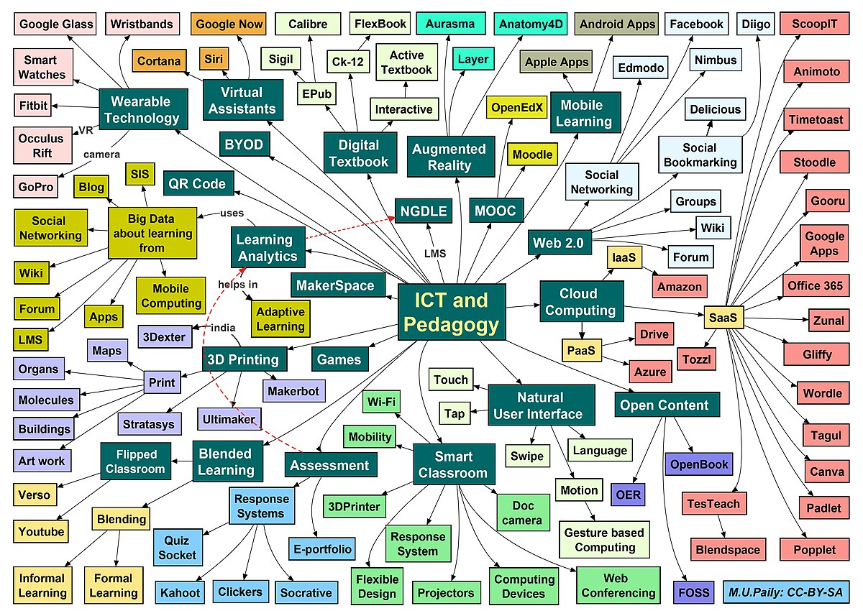

- What Is ICT?
  - Definition
ICT, or Information and Communication Technology, is an umbrella term that includes all technologies used to handle information and aid communication.
It is often considered an extended synonym for IT (Information Technology), but ICT focuses more specifically on the role of unified communications and the integration of telecommunications (telephone lines and wireless signals) and computers.
The Three Core Elements:
Information: The data being processed, stored, or retrieved (videos, text, numbers, images).
Communication: The transfer of information between people or systems (emails, video calls, broadcasting).
Technology: The hardware and software used to perform these tasks.
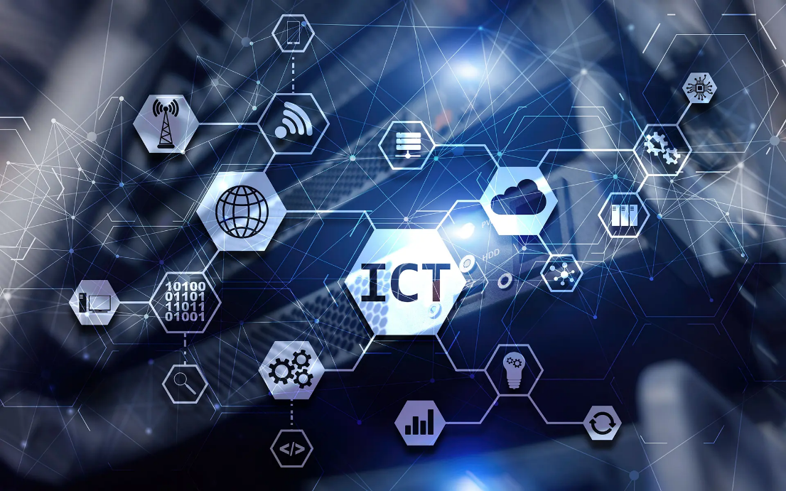
  - Importance of ICT in Modern Society.

- Economic Growth and Business Transformation:
  - Digital Economy: ICT is a primary driver of global GDP. It enables the "Digital Economy" through e-commerce platforms (Amazon, Alibaba), allowing even small businesses to reach a global audience.
  - Remote & Hybrid Work: Tools like Zoom, Slack, and Microsoft Teams have decoupled "work" from "office." This has increased productivity and allowed companies to hire talent regardless of geographical location.
  - Data-Driven Decisions: Businesses now use Big Data and AI (Artificial Intelligence) to predict market trends, understand consumer behavior, and optimize supply chains, reducing waste and increasing efficiency.
- Social Connectivity and Personal Life:
  - Instant Global Communication: ICT has turned the world into a "global village" People can maintain relationships across continents through instant messaging and video calls at almost no cost.
  - Information Access: Knowledge that used to take days of research in a library is now available in seconds via search engines, empowering individuals to be better informed.

- Governance and Smart Cities:
  - Efficiency in Public Services: Governments use ICT to provide "E-Government" services, allowing citizens to renew passports, pay taxes, and vote online, which reduces corruption and bureaucratic delays.
- Healthcare Advancement:
  - Remote Diagnosis: Through telemedicine, patients in rural areas can consult specialists in major cities via video calls, saving lives and costs.
  - Health Monitoring: Wearable devices (smartwatches) monitor heart rates, sleep, and blood oxygen in real-time, allowing for proactive healthcare and early detection of diseases.
  - Electronic Health Records (EHR): Digital records ensure that a patient’s medical history is instantly available to doctors anywhere in the world, reducing medical errors.

- Categories of ICT Technologies:

  - Communication Technologies:

Technology | Best Use Case | Impact
5G / 6G | Smart Cities & VR | Real-time Lag-free connectivity.
Satellites | Rural & Remote Areas | Global internet coverage.
Fiber Optics | National Infrastructure | High-capacity, stable data flow.
IoT | Smart Homes & Factories | Automation and data monitoring.

Table For Communication Technologies
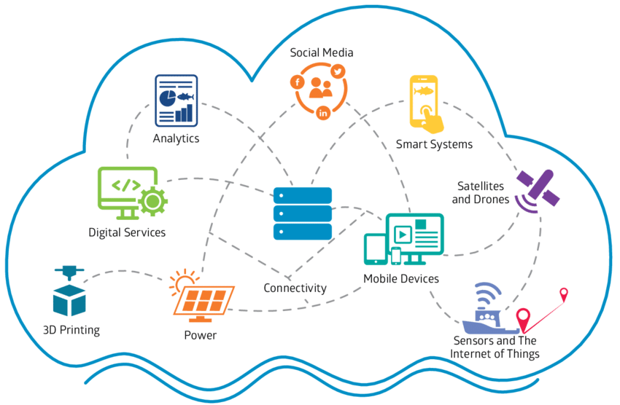

Communication Technology refers to any tool, system, or protocol that enables the exchange of information between people or machines. In 2025, these technologies have evolved beyond simple calls and texts into high-speed, intelligent networks that connect everything from your watch to industrial robots.

- Mobile Network Technologies (5G and 6G)
  - 5G (Fifth Generation): This is the current standard, offering ultra-high speeds and "low latency" (no lag). It allows for real-time applications like autonomous driving and remote robotic surgeries.
  - 6G (The Future): Currently in development, 6G aims to be 100 times faster than 5G, potentially enabling "holographic communication" where callers appear as 3D projections.
- Satellite Communications
  - LEO (Low Earth Orbit) Satellites: Companies like Star link and One Web have revolutionized this field. They provide high-speed internet to the most remote areas on Earth (mountains, oceans, deserts), effectively ending "dead zones."
- Fiber Optics
  - While we love wireless, the world's internet still travels through fiber-optic cables. These use pulses of light to transmit massive amounts of data across oceans and continents with incredible stability and speed.
- Internet of Things (IoT)
  - This technology allows "things" to communicate. Your smart home devices (fridge, lights, security cameras) use Wi-Fi, Bluetooth, or Zigbee to talk to each other and to you, creating a seamless digital environment.

  - Why Communication Technologies are Vital

- Global Collaboration: Teams spread across different continents can work on the same project in real-time as if they were in the same room.
- Instant Access to Information: From emergency alerts to educational resources, information is delivered in milliseconds, allowing for faster decision-making.
- Emergency and Disaster Response: High-tech communication allows first responders to use drones and GPS tracking to save lives during natural disasters.
- Economic Efficiency: It reduces the need for physical travel, lowering costs for businesses and reducing the carbon footprint of the global economy.

- Google Services in ICT

  - Google Workspace.
- Google Workspace is an integrated suite of cloud-based productivity and collaboration tools developed by Google. It serves as a centralized digital ecosystem designed to streamline workflows, enhance communication, and foster real-time collaboration within teams and organizations.
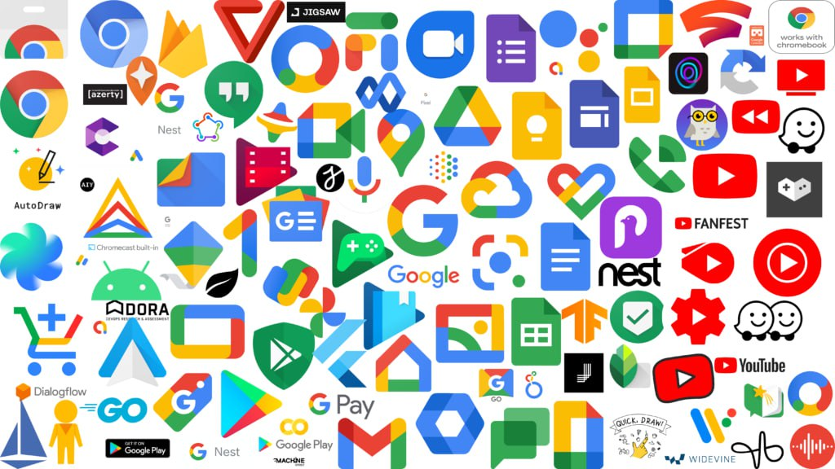
Why Google Services are Essential to ICT
Feature | Importance in ICT
Accessibility | Most services are free or low-cost, bridging the "Digital Divide."
Interconnectivity | All Google services are linked via one account, creating a seamless "Ecosystem."
Big Data | Google’s ability to process massive amounts of data helps in research, marketing, and science.
Education | Google for Education (Classroom) has become the standard for digital learning worldwide.

The core elements of Google Workspace include:
- Ubication Hub: Featuring Gmail for professional email management, Google Meet for high-definition video conferencing, and Google Chat for instant team messaging.
- Collaborative Content Creation: Tools like Google Docs, Sheets, and Slides allow multiple users to edit documents, spreadsheets, and presentations simultaneously, with all changes saved automatically in real-time.
- Centralized Storage & File Management: Google Drive provides secure, scalable cloud storage, ensuring that files are accessible from any device while maintaining advanced version control.
- Scheduling & Organization: Google Calendar facilitates efficient time management through shared schedules, meeting invitations, and seamless integration with other workspace apps.
- Security & Administrative Control: It offers robust security features, including multi-factor authentication and an Admin Console that allows organizations to manage users, devices, and data privacy from a single interface.

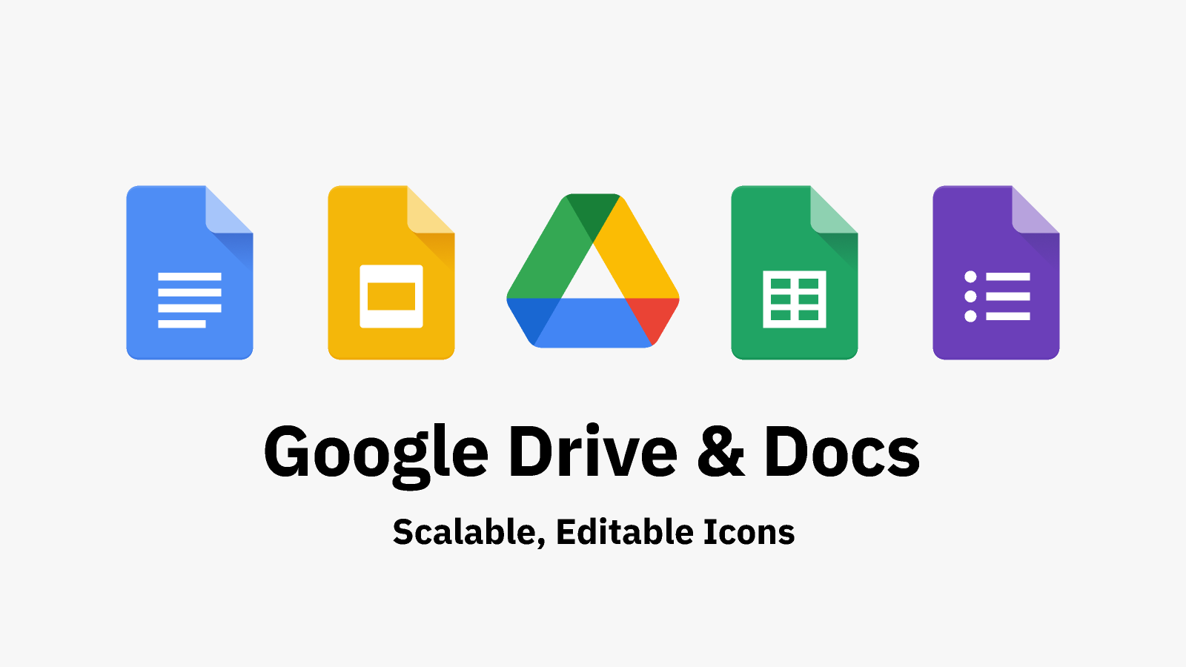

- Microsoft Tools in ICT

Microsoft Office is a comprehensive suite of desktop and cloud applications designed to facilitate professional document creation, data management, and visual communication. It remains the global benchmark for productivity in academic and corporate environments.

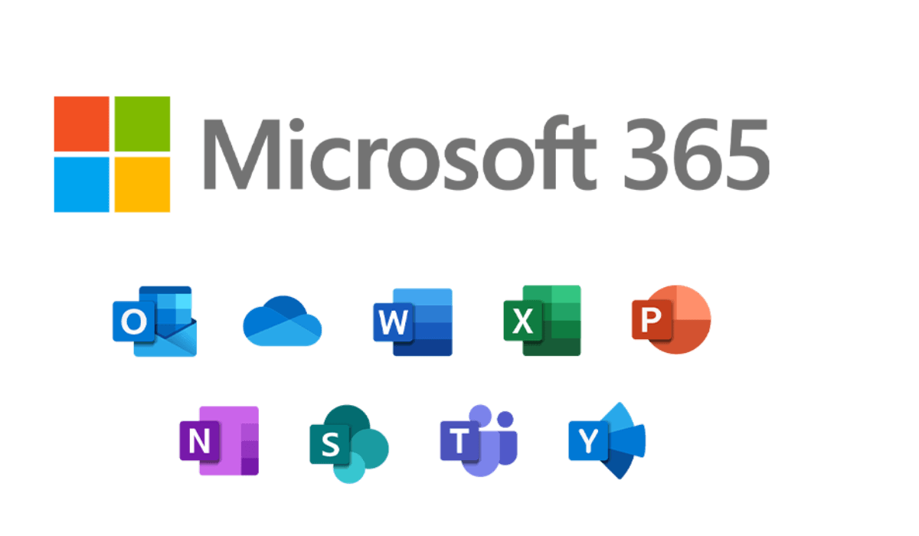

Microsoft Office provides a robust set of tools that cater to specialized professional needs. While Word handles text, Excel manages numbers, and PowerPoint delivers visuals, together they form a complete ecosystem that empowers users to produce high-quality professional output.

The primary applications:
- Microsoft Word

Word is the leading tool for creating and formatting professional documents. It offers a wide range of features, including sophisticated templates, grammar and style checking, and desktop publishing capabilities. It is essential for writing reports, letters, resumes, and academic papers with a high level of precision.

- Microsoft Excel


Excel is a powerful engine for organizing, calculating, and analyzing numerical data. Through the use of complex formulas, pivot tables, and advanced graphing tools, it enables users to perform financial modeling, statistical analysis, and database management. It is a critical tool for data-driven decision-making.


- Microsoft PowerPoint

PowerPoint is designed for visual storytelling and professional presentations. It allows users to combine text, images, animations, and multimedia to deliver impactful messages. With its diverse slide layouts and transition effects, it helps speakers communicate complex ideas effectively to an audience.

- Microsoft Outlook

Microsoft Outlook is a professional personal information manager that goes beyond simple email exchange. It serves as the primary communication hub for organizations, integrating email, scheduling, and task management into a single, unified interface.

- Introduction To Git & GitHub

  - What is Git?
Git is a free, open-source distributed version control system designed to handle everything from small to very large projects with speed and efficiency.


- Version Tracking: It records every change made to a file, allowing developers to "time travel" back to any previous state of the project.
- Local Management: Git runs locally on a developer's computer. You don't need an internet connection to track your changes or create new versions.
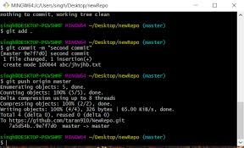
- Branching & Merging: It allows developers to create "branches" to work on new features safely without affecting the main code. Once the feature is ready, it can be merged back.
- Data Integrity: Every change is cryptographically hashed, ensuring that the code history cannot be altered or corrupted without notice

  - What is GitHub?
GitHub is a cloud-based hosting service that lets you manage Git repositories. It provides a web-based interface and additional tools for team collaboration.



- Cloud Hosting: It provides a remote location on the internet where teams can store their Git repositories, making code accessible from anywhere.
- Collaboration Tools: It introduces features like "Pull Requests" and "Code Reviews" where team members can discuss changes, suggest improvements, and approve code before it is merged.
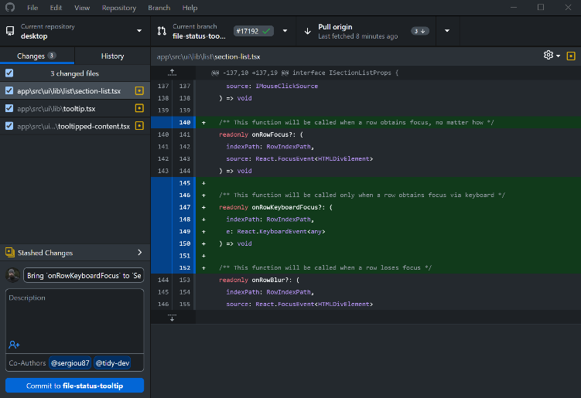

- Project Management: GitHub includes non-coding tools such as "Issue Tracking" "Project Boards," and "Wikis" to help teams organize their tasks and documentation.
- Social Coding: It acts as a social network for developers, allowing them to follow projects, contribute to open-source software, and showcase their work (portfolios) to potential employers.

- Case Studies & Examples

  - How ICT Improves Daily Work

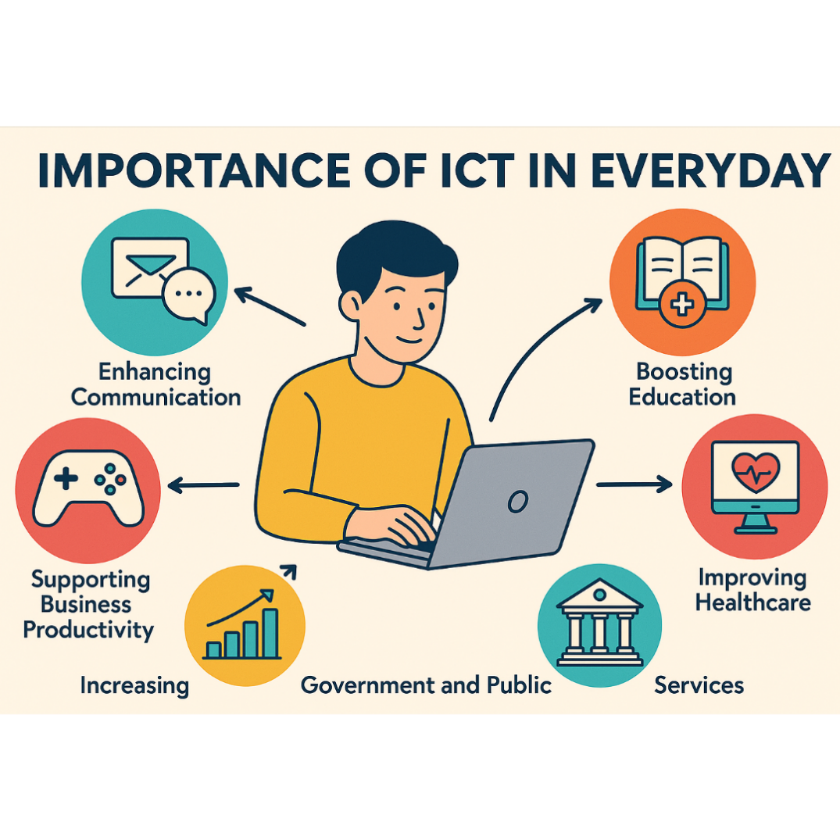
The integration of ICT tools has fundamentally changed the modern professional landscape by replacing manual, time-consuming tasks with automated digital workflows.

- Enhanced Connectivity: Tools like Microsoft Outlook and Gmail have turned communication into an instantaneous process, allowing for global networking without delays.
- Seamless Collaboration: The use of Google Workspace and Microsoft Office 365 enables "asynchronous" and "synchronous" teamwork. Multiple employees can contribute to the same project from different time zones, ensuring continuous progress.
- Data-Driven Efficiency: High-speed data processing in Excel or Google Sheets allows workers to manage complex datasets in minutes, a task that once took days of manual calculation.
- Workflow Flexibility: Cloud technologies like Google Drive provide the "Office in a Pocket" experience, allowing professionals to access critical files and work from home, transit, or traditional offices with equal productivity.

  - Real-World Applications
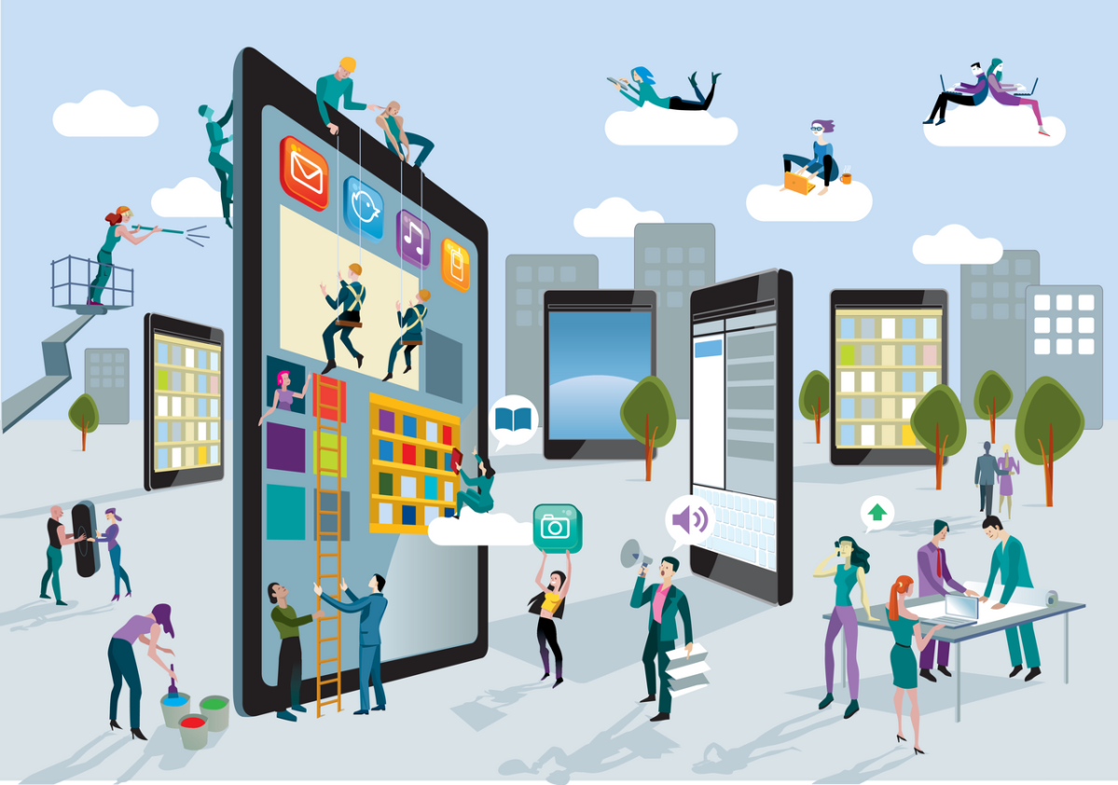
ICT is not limited to office work; it has revolutionized every major sector of the global economy:
- Healthcare (Telemedicine & EHR): Digital systems allow doctors to access electronic health records instantly and consult with patients remotely, significantly improving diagnostic speed and patient outcomes.

- Education (E-Learning Platforms): Platforms like Google Classroom and Canvas have democratized education, providing students worldwide with access to high-quality resources, interactive assignments, and virtual lectures.

- Finance (Digital Banking & Fintech): The banking industry relies on ICT for secure, real-time transactions, mobile banking apps, and automated fraud detection, making financial management faster and safer for billions.

- Software Engineering (DevOps): The combination of Git and GitHub has standardized the way software is built. Open-source projects and corporate software development now rely on these tools to maintain code quality and manage global contributions safely.

- Conclusion
In conclusion, Information and Communication Technology (ICT) has evolved from a luxury to an absolute necessity in the modern era. As explored throughout this project, tools like Google Workspace and Microsoft Office have redefined productivity by enabling seamless collaboration and professional data management.
Meanwhile, systems like Git and GitHub have revolutionized the way technical projects are built and shared globally. ICT is more than just a collection of software; it is a powerful ecosystem that bridges geographical gaps, accelerates innovation, and empowers individuals and organizations to achieve greater efficiency.
As we look toward the future, the continuous advancement of these technologies will undoubtedly remain the driving force behind global progress and digital transformation.

